Joshua Jacob Mauricio

Feature Wireframes and Descriptions

**Feature 1:** Homepage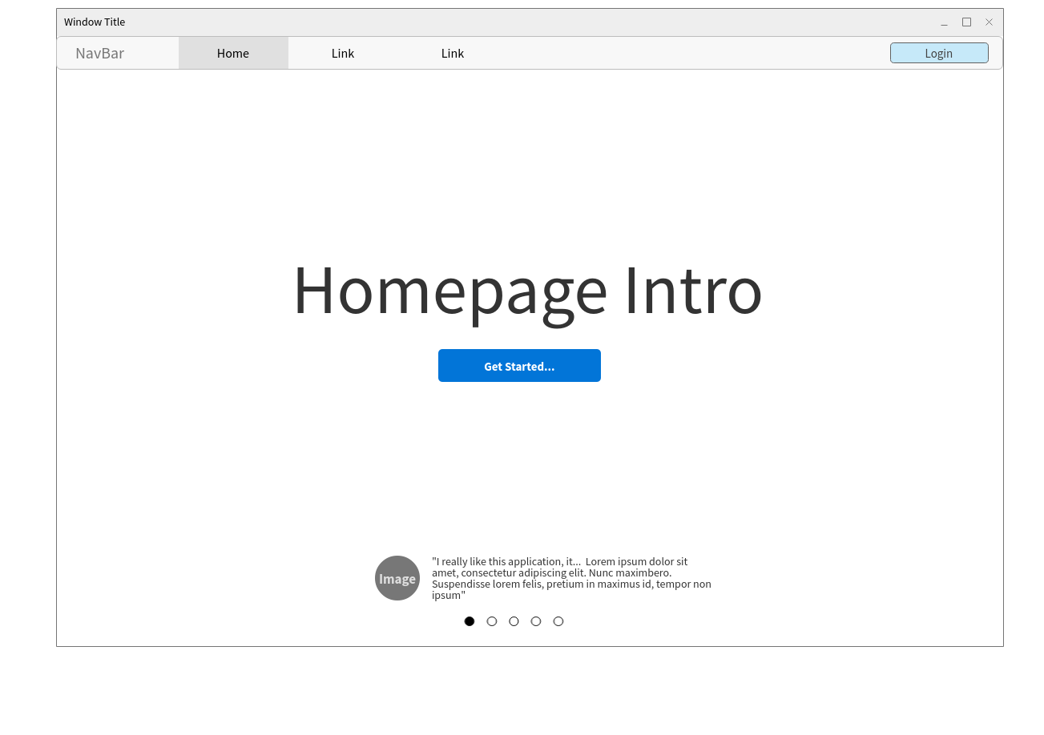

Description:

This homepage is simple and would be a non-cluttered view when visitors and users first come to the website. There would be a simple message that simply states a welcome or some type of message/phrase that describes what the website is about. On the bottom of the page, there would also be user reviews of this website that includes some type of user image/avatar, the user name, and the user comment/review statement. There will be multiple reviews that visitors/users can scroll through when first coming to the site.

**Feature 2:** Login

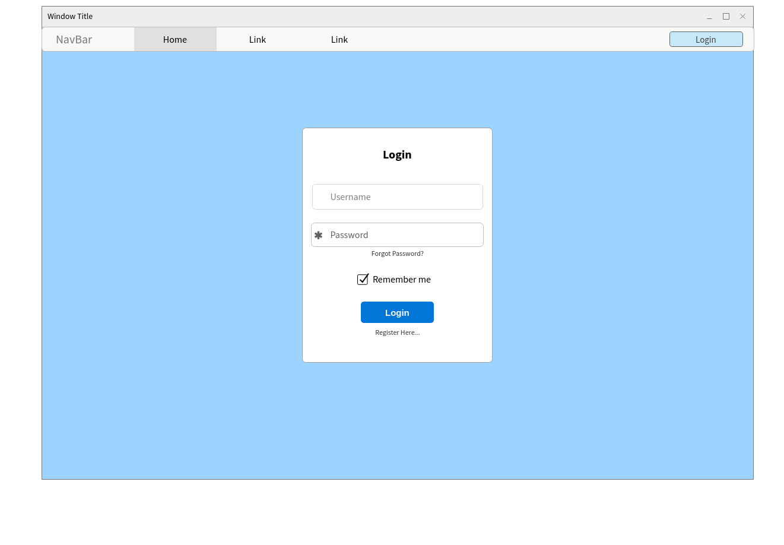

Description:

This is a simple login page that is very necessary for users to sign in. Users will also have the option to have the system remember them so that they don't have to login manually again, a forgot password feature, and a register feature.

**Feature 3:** Feature Page

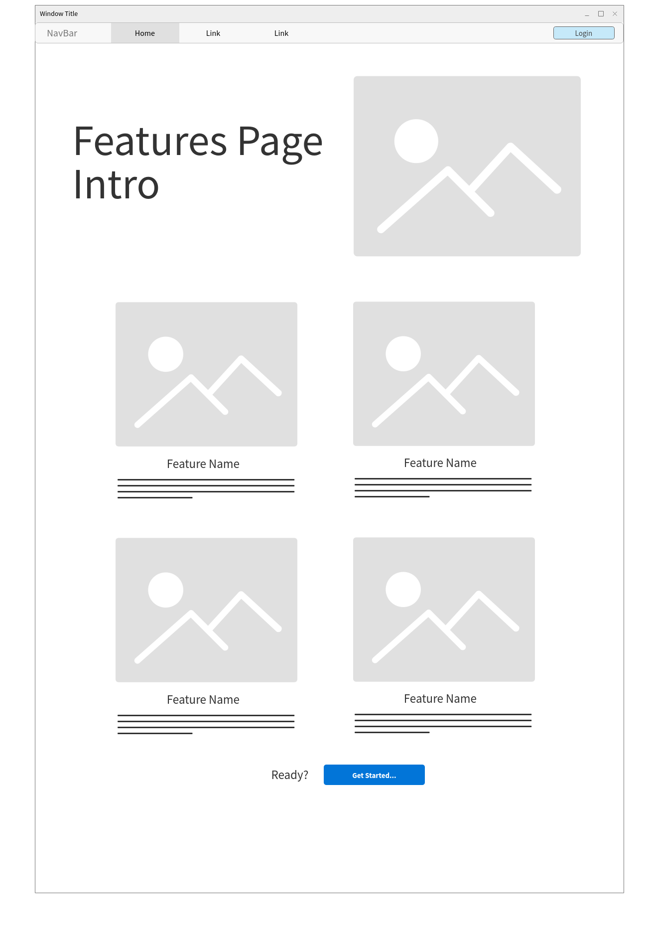

Description:

This feature page is also fairly simple. On this page, there will be an initial description and image of what this specific page is about. Following the intro, there will be the list of notable features that come along with the website. Each feature that is listed will have a simple image designed by someone in the group, followed by the feature name and the description of the feature. Clicking on the name or the image of a feature will allow take the user to that specific feature/page. On the bottom of the features page, there will also be a "Get Started…" button that gives the user the opportunity to sign up/login into their account.